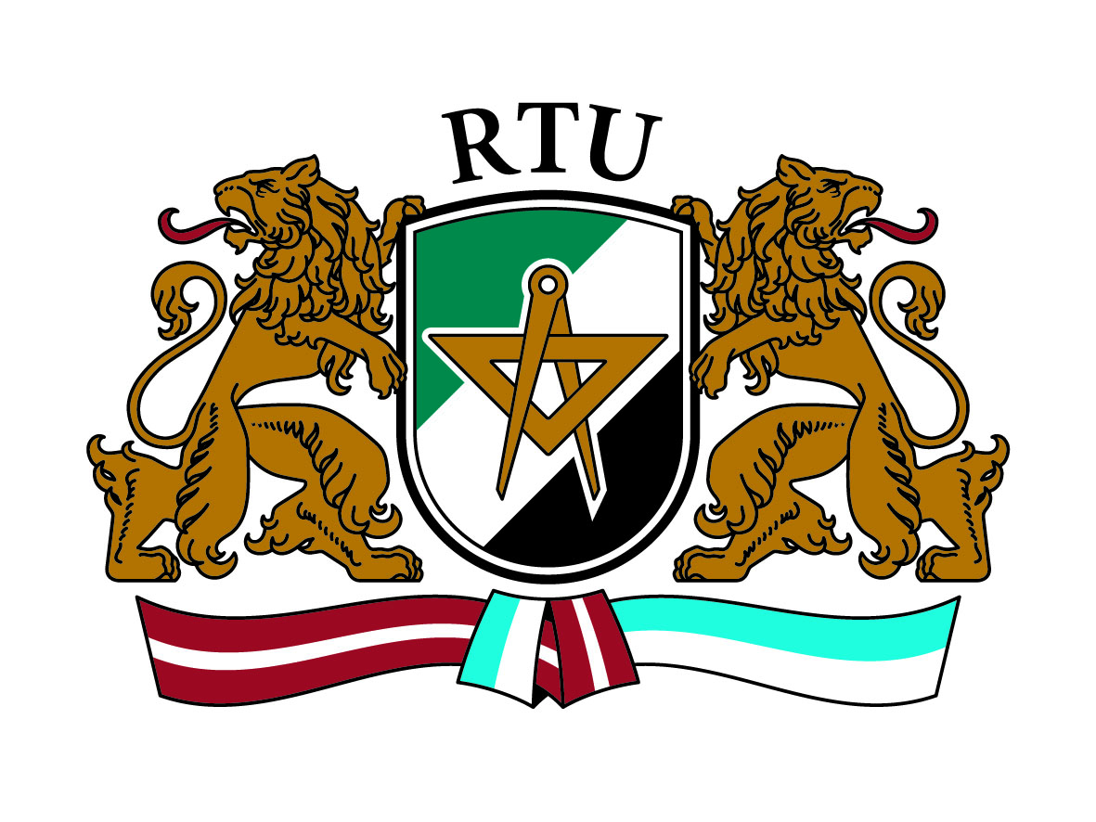 | Application Form  2ND INTERNATIONAL STAFF TRAINING WEEK  May 27 – 31, 2013  Riga Technical University

Title:
Surname:
Name:
City and country:
University:
Department:
Position:
Main responsibilities:

Contact data:
Address
E-mail
Telephone / mobile

Erasmus code:

Name and e-mail of Erasmus coordinator at your institution:

Reasons for wishing to participate at the Erasmus Staff Week 2013 organized by the RTU:

According to the planned programme, I will join:
- Individual meetings (will be organised according to your interests):
Please tick off | YES | NO
Faculty of Architecture and Urban Planning
Faculty of Civil Engineering
Faculty of Computer Science and Information Technology
Faculty of Electronics and Telecommunications
Faculty of Engineering Economics and Management
Faculty of Materials Science and Applied Chemistry
Faculty of Power and Electrical Engineering
Faculty of Transport and Mechanical Engineering
Riga Business School
Institute of Applied Linguistics
Library
International Relations Department
Foreign Students Department
Other interest (please specify):
- Welcome dinner
- Riga city tour
- Tour to Jūrmala (www.jurmala.lv)

Please send your completed application form before April 22nd 2013 to e-mail liene.maurite@rtu.lv

